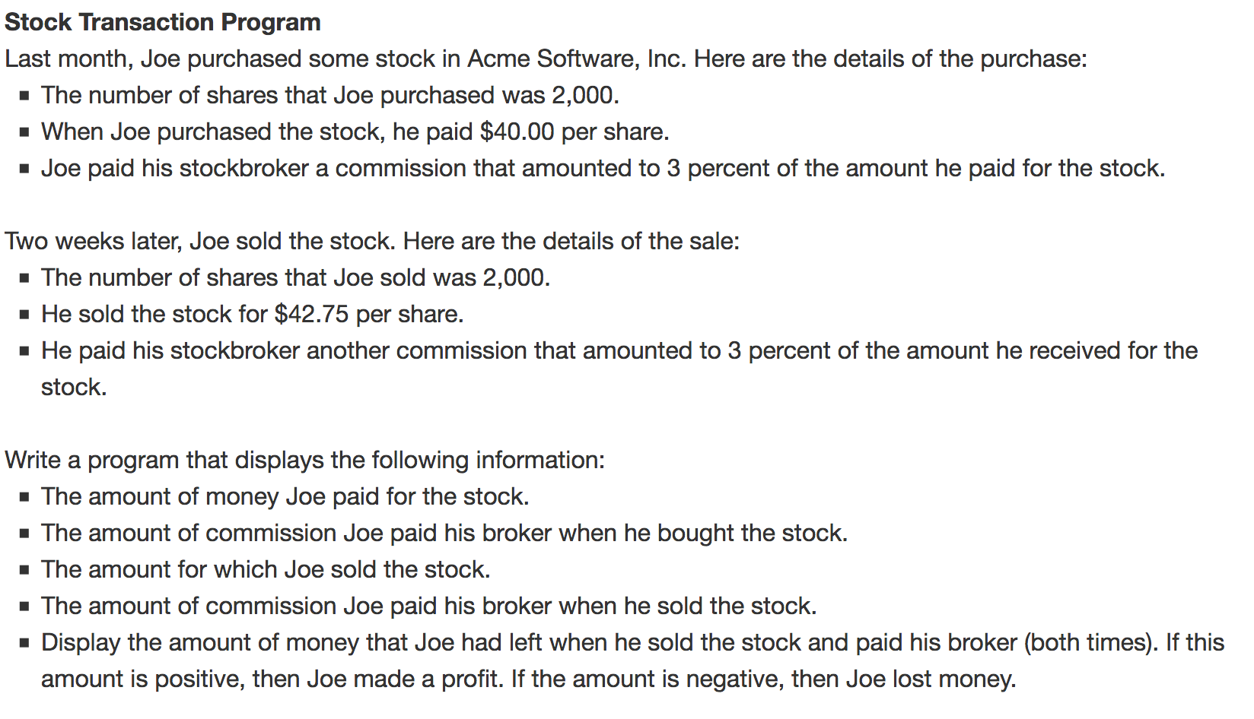

**What to submit on blackboard?**

1. Submit your program source code listing.
2. Submit your program output. Please provide several test results, not just one output test result. Failure to submit your program output will lose 1/3 of your overall assignment points.